**How to apply using the Online Application Centre**

1. Go to [www.federation.edu.au](http://www.federation.edu.au)
2. Type Course name: ‘Advance to University’ or Course code ‘XC17’
3. Select Advance to University course.



1. Once you are in the Advance to University page, you will be able to commence an online application by clicking ‘Apply Now’



1. You will need to Register as a New Applicant by selecting ‘First time applicant’ if you have never applied to study with Federation University directly, Once registered you are able to select ‘Login’ with your existing details as a returning applicant.



1. 1: Login/Register: When Registering as a new applicant please fill in all required fields and complete the ‘Captcha Challenge’, then click the ‘Register and Begin Application’

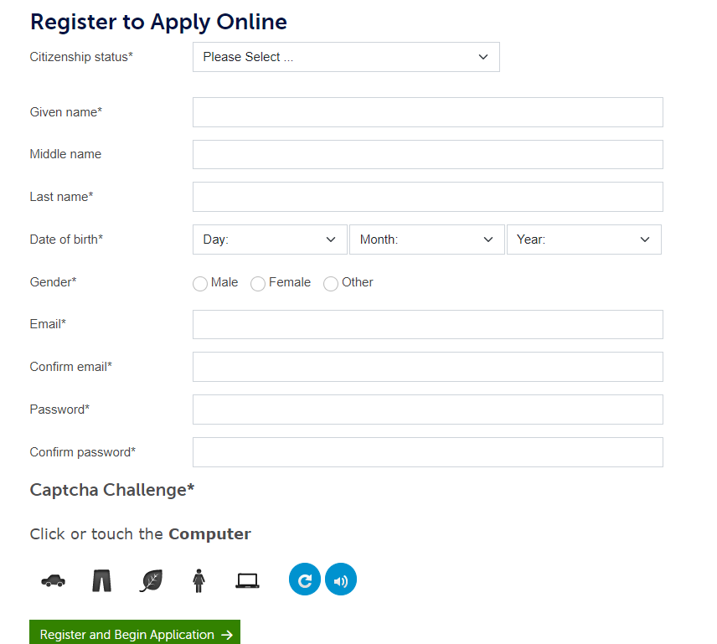

1. 2. Program details

* Select Semester 1 2025
* Search Advance to University (if not already populated)
* See results at the bottom of the screen
* Select relevant location

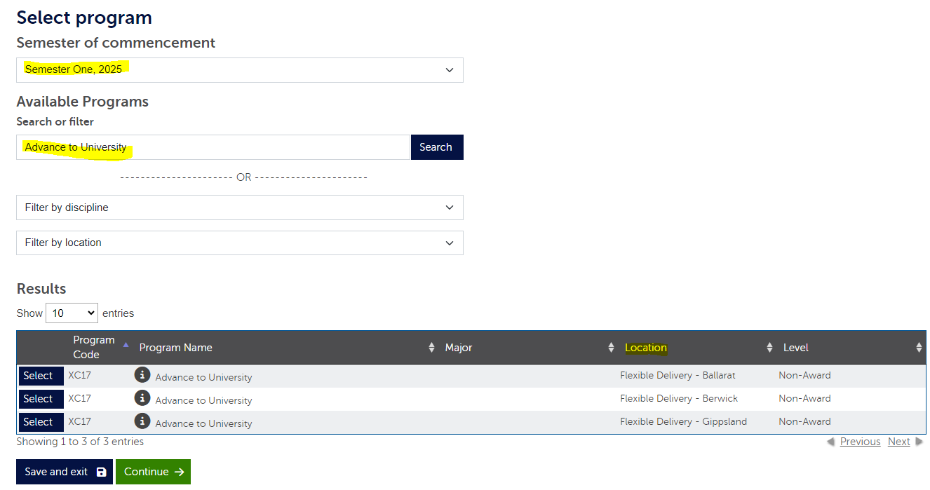

1. Once selected relevant Campus for Advance to University. Selection will show up on the right, Ensure that information is correct before selecting ‘Confirm selection’

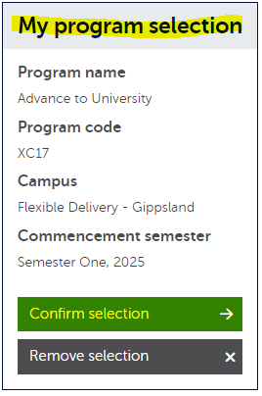

1. 3 Personal details: Please fill in your Personal Details then click ‘Continue.



1. 4. Supporting information. Select the options highlighted below. Click ‘Next’

* Please note: You will not be required to complete anything further on this page.

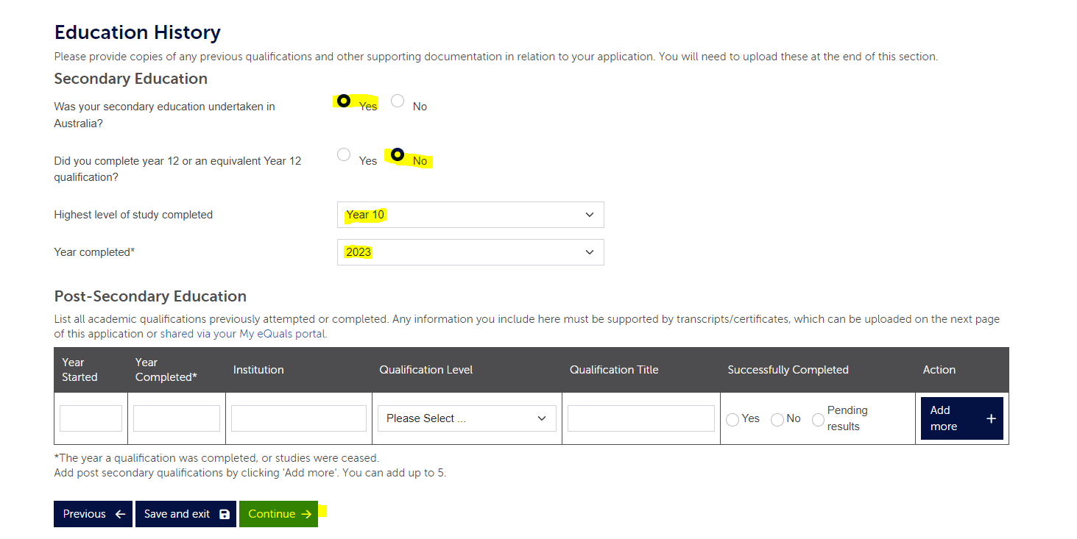

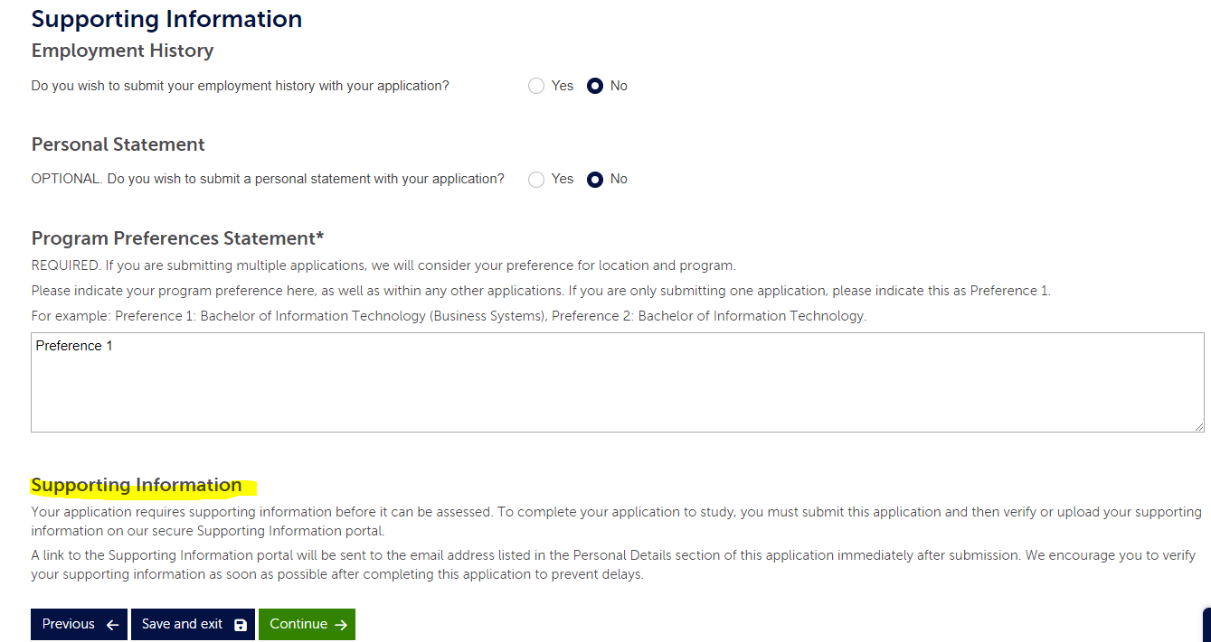

Please read the supporting information. This will assist you with the next steps of the application

1. Verify your submissions details ensuring all information is correct.  
   Click ‘Continue
2. Read the Declaration and select the appropriate option at the end  
   Click ‘Submit Application’
3. You should receive a confirmation application number once you have submitted your application

As per the information above you will receive an email with further information. We will commence assessing your application once all required documents are attached.

Good luck for your future Application!