NO: | FIND: | HINT: | ANSWER:
1. | 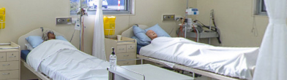 | Where you go when you need to be looked after
2. | 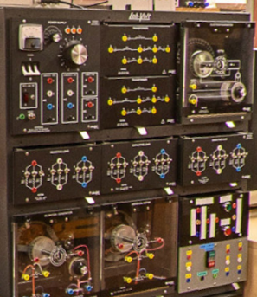 | You wouldn’t want to see a bright spark here!
3. | 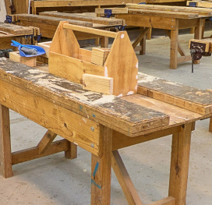 | Measure twice, cut once.
4. | 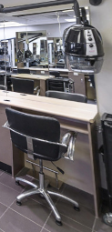 | Do you have an eye for style?
5. | 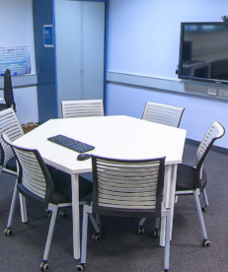 | IT or Games, it happens here
6. | 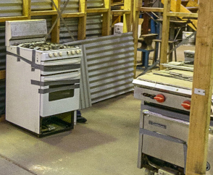 | When it isn’t just about blocked pipes.
7. | 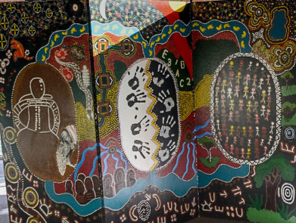 | Where you are welcomed to Campus
8. |  | A quiet place to research or study.
9. |  | Do the PC’s need medical attention?
10. | 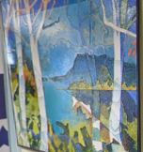 | Making another entrance

Answers:

- M – Nursing. All our campuses have purpose-built units that mirror the hospital environment, where learning is based on real and complex clinical scenarios that require various levels of care.

- A – Electrotechnology. Kickstart an electrical career.

- M – Building and Construction. This industry is crucial to our local and national economy and plenty of opportunities to carve out a career across several trades.

- M -Hairdressing.

- M – Digital Media Lab

- M – Plumbing

- M – Grampians Foyer

- C - Wimmera Library

- M – Computer Lab

- C - Wimmera Foyer

