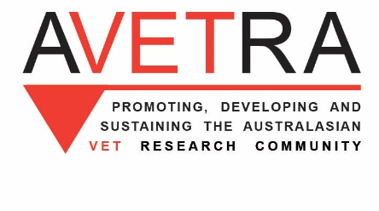
Learning in turbulent times
A free online research-based event, Mon16th November 2020, 6pm-8pm AEDT
Please support Ballarat’s thirteenth annual OctoberVET event, mounted by Fed Uni’s
VET research group RAVE – Researching Adult and Vocational Education
https://federation.edu.au/schools/school-of-education/research/research-groups/rave-researching-adult-and-vocational-education
Speakers and topics
Young people and the COVID-19 labour market: Insights from ‘PISA 2018’
Anthony Mann, Organisation for Economic Co-operation and Development
The current healthcare pandemic is creating an employment crisis for young people. In such circumstances, it is imperative that schools work effectively to enhance student preparation for the work. New OECD analysis draws on (i) insights from national longitudinal datasets in Australia and other countries to identify teenage indicators of career readiness and (ii) data from the 2018 OECD Programme of International Student Assessment (PISA) to compare career readiness between and within countries. A particular focus in the presentation will be on young people’s interests in the skilled trades access through vocational education and how they vary by social characteristics. The presentation introduces ongoing OECD work on effective practice in the pandemic.

Researching men's sheds: Opportunities for international collaboration
Barry Golding
Coronavirus information – a question of trust? Survey results on learning about the pandemic
Erica Smith & Morgan Wise, Federation University
Community learning through adversity and disaster: An Australian case study of rural adaptation and resilience
Annette Foley and Barry Golding, Federation University
Monday 16th November 2020, 6.00pm – 8.00pm, Melbourne time
Registration via survey monkey link
https://www.surveymonkey.com/r/BQVVWSV
Please note, this is an online event and we are limited to 90 participants. Please register early to secure a place.
Enquiries to vet.research@federation.edu.au

‘OctoberVET’ is an initiative of the Australian VET Research Association (AVETRA).
AVETRA is committed to building and promoting research capability to ensure a rigorous and well informed VET system. OctoberVET is the name given to a series of events held throughout Australia to showcase VET research. www.avetra.org.au
Other 2020 OctoberVET events nationally can be seen at http://www.avetra.org.au/pages/octobervet-.html

OctoberVET Ballarat 2020 speakers
Dr Anthony Mann is Senior Policy Analyst at the OECD where he has led work on international comparisons and effective practice in relation to vocational education and training, career readiness and school to work transitions.
Anthony has published on employer engagement in education and on VET systems in several countries. His most recent publication is Schoon, I. & Mann, A. (2020). School-to-work transitions during coronavirus: Lessons from the 2008 global financial crisis. OECD Education and Skills Today. May 19. https://oecdedutoday.com/school-work-during-coronavirus-2008-global-financial-crisis/
Conference participants are invited to connect with the OECD research team via Anthony.Mann@oecd.org.

Professor Erica Smith is Professor of Education in the School of Education and leader of the Researching Adult and Vocational Education (RAVE) group. Erica is Australia’s foremost apprenticeship researcher, and is co-chair of the International Network on Innovative Apprenticeship (INAP). Erica is also an expert on VET teachers, their work and qualifications. Other areas of expertise include VET policy, training in workplaces, competency-based training, and the school-to-work transition. She leads a VET teacher-education program and convenes the Australian Council of Deans of Education Vocational Education Group (ACDEVEG). She is an appointed member of the Australian Government’s Education Industry Reference Group. Erica makes many invited contributions to Commonwealth and State government policy and practice in her areas of expertise, and has advised governments in several other countries. She has managed over 30 national and international research projects, and is an invited speaker at events around the world.
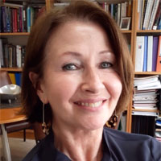
Associate Professor Annette Foley joined Federation University in 2005. She has held several leadership positions, as Deputy Dean Education and Head of School Education. Annette has first-hand experience as a TAFE manager and CEO in a VET/ACE and youth services organisation, where she liaised and worked with industry, community and local government agencies to develop education and training programs for young and older learners Annette’s key research efforts which include: Access and equity, informal learning, gender, lifelong learning, adult education, education for health and well-being, youth engagement in adult education and Vocational Education and Training (VET) opportunity and pathways. Annette is on the Editorial Boards for the Australian Journal of Adult Education (AJAL) and Studies in Adult Education and Learning.

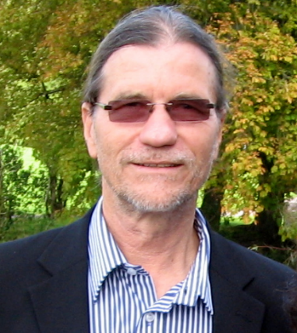
Barry Golding AM is an Adjunct Professor at Federation University Australia. Barry has extensive research experience in vocational, adult and community learning His focused mainly on equity and access to learning in less formal community contexts. His recent international emphasis has been on men’s informal learning through participation in community organisations. He has completed many national and international studies of older men’s learning and wellbeing through community participation including through Men’s Sheds internationally. His recent Australian field research has included studies of alternative schools and vocational education for young people in regional and rural settings. Barry is honorary Patron of the Australian Men’s Sheds Association, former President of Adult Learning Australia and in 2016 was awarded the Member of the Order of Australia (AM).
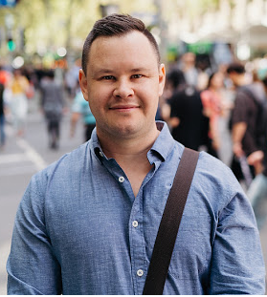
Morgan Wise is a registered mental health nurse with a double degree in social sciences and humanities (majoring in psychology) and mental health nursing. Morgan completed a graduate diploma of mental health nursing, and a Masters of mental health nursing within the acute mental health setting. Morgan is currently employed by Ballarat Health Services’ Intensive Outreach Team specialising in supporting those with severe mental health disorders, by Ballarat Innovation and Research Collaboration for Health (BIRCH) and by Federation University, in a research assistant capacity. Morgan has an interest in health focused research and has worked in research for 10 years with co-authored academic papers and reports, and several conference presentations. Morgan sits on the implementation advisory committee for the ‘Equally Well in Victoria’ project aimed at improving health outcomes for mental health consumers.

