How to apply for Advance to University with Federation University
Step 1 Go to https://apply.federation.edu.au/
Step 2 Select ‘First time applicant’ to register as a new applicant proceed to step 3. Or select ‘Returning applicant;’ if you have previously registered, and skip to step 4.
Step 3 In the ‘1. Login/Register’ tab fill in personal details in the required fields, complete the ‘Captcha Challenge’, and then click the ‘Register and Begin Application’.
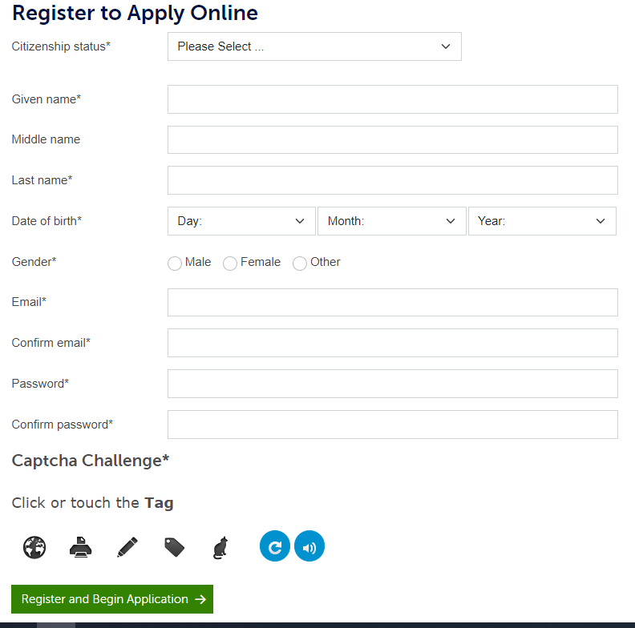
Step 4 In the ‘2. Select Program’ tab selection the correct program:
- Under ‘Semester of commencement’, click on the dropdown box and select ‘Semester 1, 2024’
- Search ‘Advance to University’
- See results at the bottom of the screen
- Click ‘Select’ on the program that matches your preferred location.
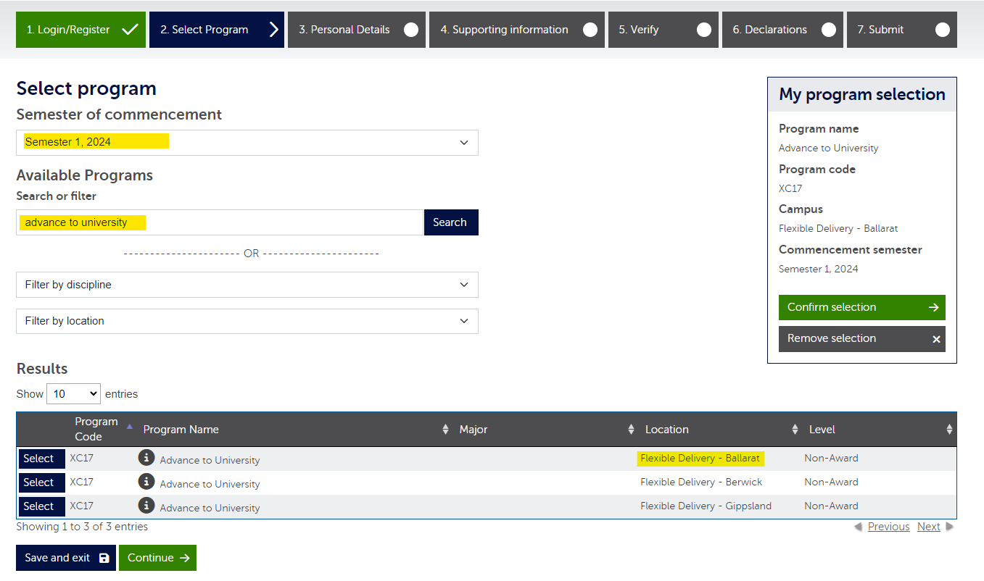
- In the ‘My program selection’ box, click ‘Confirm selection’ ensuring all information is correct first.
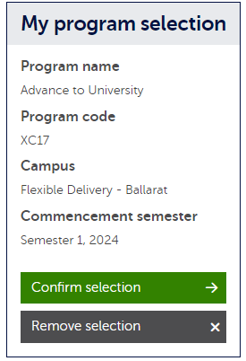
Step 5 In the ‘3. Personal Details’ tab, fill in the required fields and then click ‘Continue’.
Step 6 In the ‘4. Supporting information’ tab, complete the questions under the ‘Secondary Education’ heading, then scroll to the bottom of the page and click ‘Continue’.
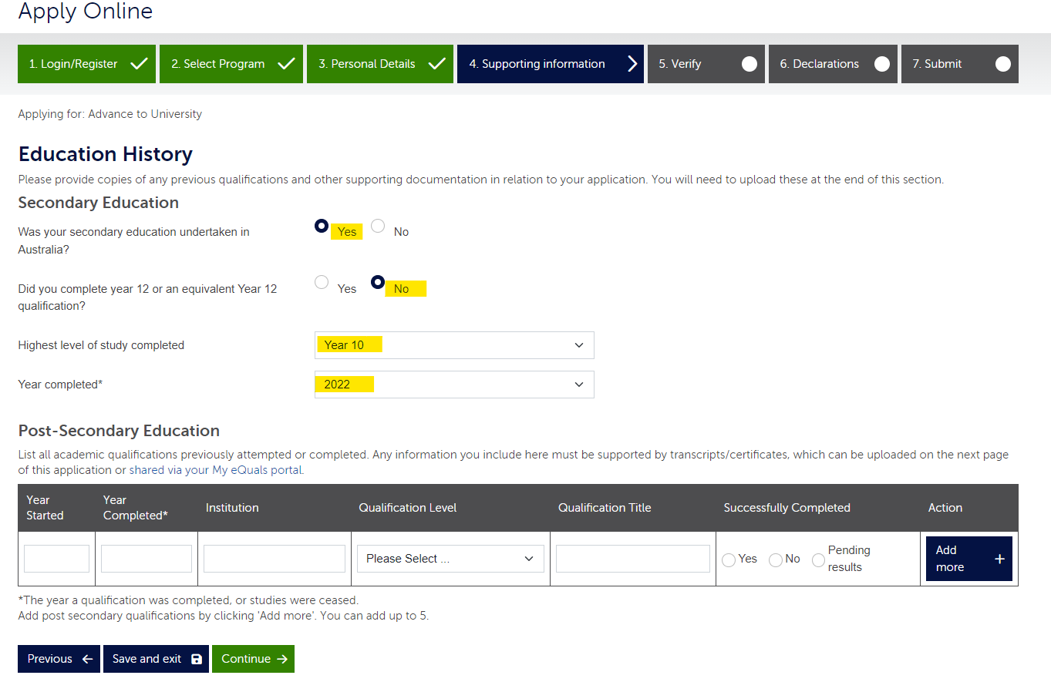
Step 7 Still in the ‘4. Supporting information’ tab, in the ‘Program Preferences Statement*’ box type ‘Advance to University’, then click ‘Continue’.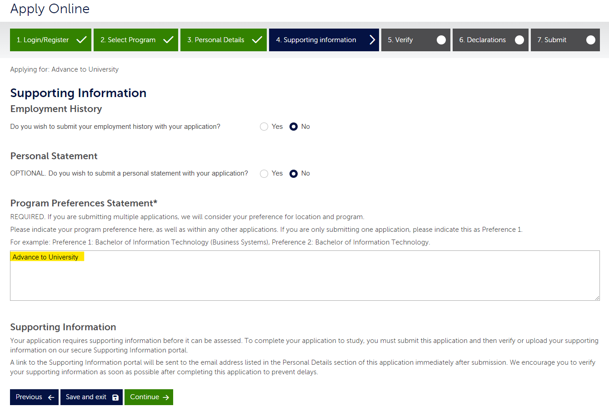

Step 8 In the ‘5. Verify’ tab, check all details are correct and then click ‘Continue’.
Step 9 A pop up titled ‘Important information about your application’ will appear. Read before clicking ‘Ok’.
Step 10 Read through the Declaration before accepting and then click ‘Submit Application’.
Step 11 Note down your application number for future reference.
Step 12 Supporting information is required to assess your application. After submitting your application, you will receive an email asking you to verify or upload your supporting information on our secure Supporting Information portal. You must complete this step to progress your application.

