NO: | FIND: | HINT: | ANSWER:
1 | 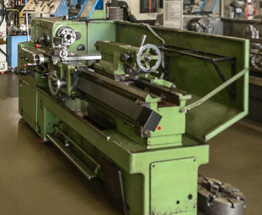 | Where you get to play with little and big toys.
2. | 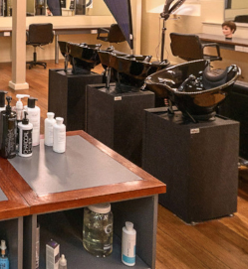 | Where you can get a bit of pampering to look and feel good.
3. | 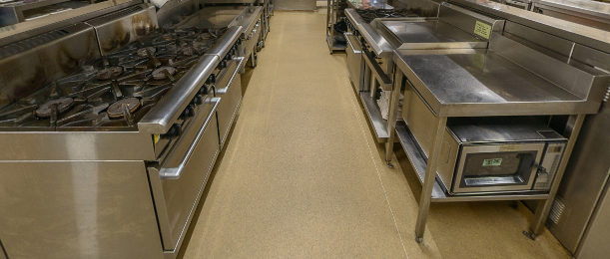 | When you have that hunger in your belly!
4. | 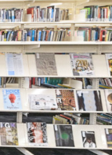 | Where you will find an infinite amount of study resources.
5. |  | This is where learning can start at a young age.
6. | 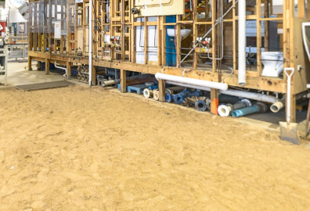 | Do you know where you get to play in a sandpit as part of your studies?
7. | 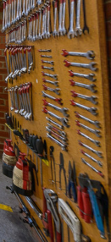 | Where you will learn how to keep motoring along.
8. | 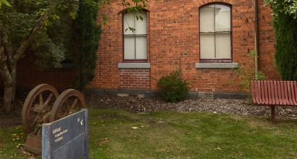 | In the past as a law-abiding citizen you would not have spent time here.
9. | 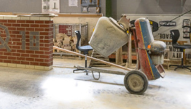 | This is where you can learn to build a solid foundation.
10. | 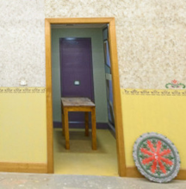 | This is where your artistic flair and eye for detail comes in to play.

ANSWERS:
1. S-Mechanical Engineering
Our programs are taught by industry-experienced professional teachers and reflect the needs of industries deploying the latest technologies and equipment.

2. P – Hairdressing
SMB houses a commercial salon where our leading hairdressers and beauticians train students and develop their skills. We offer a range of discounted services to students, staff and the public to help students gain experience.

3. Prospects Restaurant is home to two large commercial kitchens and operates a s fully functional restaurant staffed by our teachers and students – the perfect place to learn, hone and test out your culinary skills.

4. G – Library
The library provides information in the form of books, journals, newspapers, eBooks, databases and online journals, articles and audio-visual materials.
Recreational and general interest books, newspapers and journals are also available

5. Liz and Bob Smith Children’s Centre – Centre for Early Childhood Education

6. R – Plumbing Sandpit

7. H - Automotive
Gain the skills needed to diagnose, repair and maintain the technologically advanced vehicles we drive today.

8. Old Gaol Courtyard
The Ballarat Gaol was built in 1887 to replace the wooded structure that was erected on the site in 1854. There was a tunnel connecting the prison with the courthouse.
The prison held both male and female prisoners: it had 58 cells and could hold 74 prisoners.

9. Q – Bricklaying

10. R – Painting and Decorating
There are plenty of opportunities to carve out a career across several trades in the building and construction industry that is crucial to our local and national economy.

