You need to work out who your audience is – where they are on social media, and how you’re going to reach them.
Knowing more about your audience allows you to think about them when you’re creating content – put yourself in their shoes and think about what they might want to receive, and how they might react.
Here is an example:
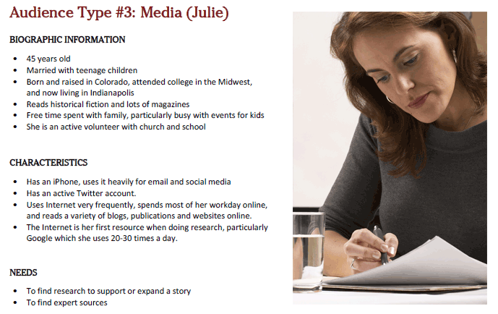

(source: http://blog.tbhcreative.com/2013/01/know-your-audience-value-of-audience.html)

Complete this table.
You may find it easiest to determine your goals first.
Be creative and have fun - it is a great group activity.
Give your personas a name and find a photo on the internet that represents them.
It’s not unusual to have more than 4 different personas. Regularly refer back to this doc and update if necessary.
 | What do they do? | Where are they at? | Confidence points or issues | What do they want? | What frustrates them? | Why do they stand out? | What Social Media do they use?
Name & photo
 | - Work status  - Education level  - Hobbies | - Age  - Gender  - Marital status  - Family status
Name & photo

Name & photo
Name & photo
Name & photo

