Recommended Maximum Lifting Weights

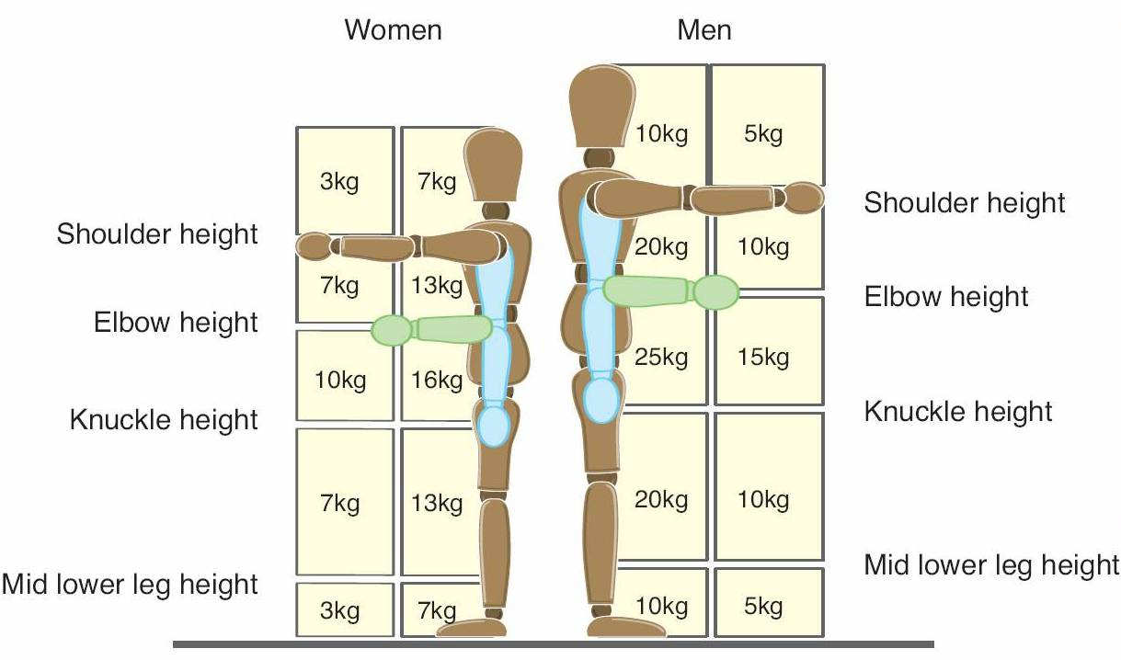
TIPS

Keep the load close to the waist:

Keep the load close to the body for as long as possible while lifting

Keep the heaviest side of the load next to the body.

Adopt a stable position:

Feet should be apart with one leg slightly forward to maintain balance.

Be prepared to move your feet during the lift to maintain stability.

Start in a good posture and maintain it throughout the lift:

At the start of the lift, slight bending of the back, hips and knees is preferable to fully flexing the back (stooping) or fully flexing the hips and knees (squatting).

Don’t flex the back while lifting.

Avoid twisting the back or leaning sideways.

Keep the head up when handling.

Move smoothly.

