NO: | FIND: | HINT: | ANSWER:
1 | 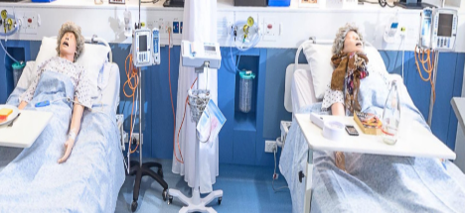 | Where do you go when it all gets a bit much?
2. | 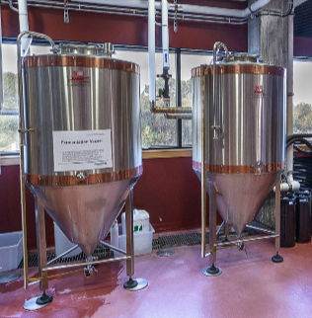 | Do you have a good idea brewing?
3. | 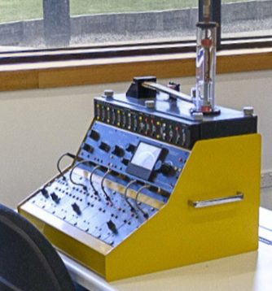 | Sometimes you need to know the right buttons to push
4. | 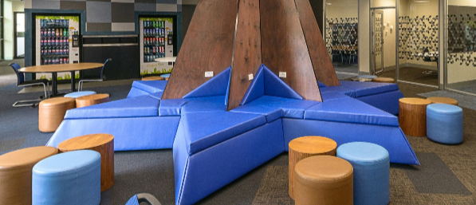 | Which building is the first Federation University building to be officially given an Aboriginal name?
5. | 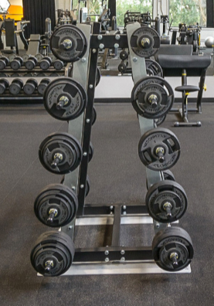 | Where can you go to get strong in body and mind?
6. | 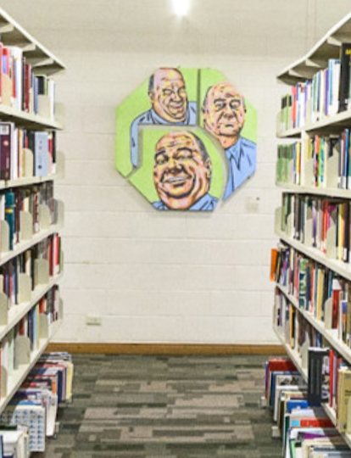 | Where can you find an infinite amount of resource material?
7. | 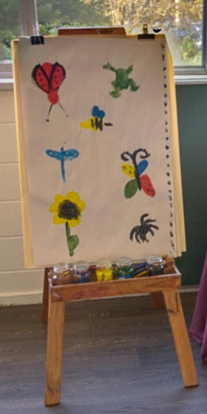 | Where you think it will be all fun and games with the little people?
8. |  | Where do you expect you will be lectured?
9. | 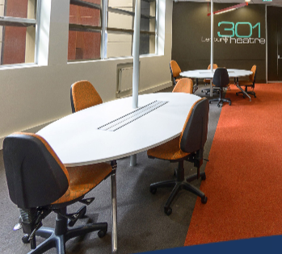 | When can you go to study afterhours?
10. |  | Which Office can provide assistance in relation to your studies for current and future students?

ANSWERS:
- S – Nursing
- Y – Micro Brewery.
In the Science and Technology Building students can learn the science and processes of authentic brewing
- Y – Engineering
Many of our engineering and information technology programs provide accreditation with professional bodies and all programs are recognised for the industry experience, engagement, and practical field work that they provide.
- Gnarrwirring Karung (pronounced Narrowing Ker Ung), meaning Learning Place in the local Wadawurrung language.
- Health and Fitness Centre.
Advantages of being a member include:
Regular fitness assessments
Personalised exercise programs
Sports science and health and well-being advice
Nutritional guidance
All in a friendly and relaxed atmosphere
- Federation University Library.
The library provides information in the form of books, journals, newspapers, eBooks, databases and online journals, articles and audio visual materials.
Recreational and general interest books, newspapers and journals are also available
- E – Early Childhood
Our early childhood programs are fast growing in reputation due to their quality of curriculum and genuine commitment of teaching staff to the success of each student.
- C -The Geoffrey Blainey Auditorium.
The auditorium incorporates a state of the art 350 seat lecture theartre fully equiped with data, video and slide projection. In addition the complex also incorporates 4 smaller workshop rooms.
- Study Spaces, comfortable afterhours study spaces are available on campus
- Student HQ.
Student HQ can provide assistance in person, online or over the phone

