NO | FIND | HINT | ANSWER
1 | 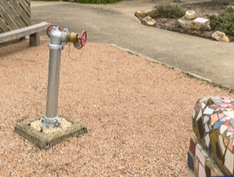 | Even necessary items such as a firefighting tap are readily ‘displayed’
2. | 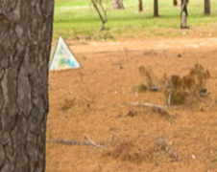 | Find the Triangle sculpture.  You might not see it amongst the trees
3. | 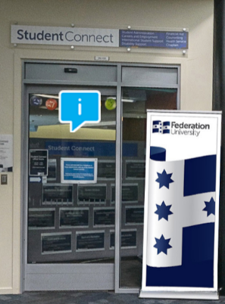 | Where will you find full access to a comprehensive range of Health and Wellbeing Services?
4. | 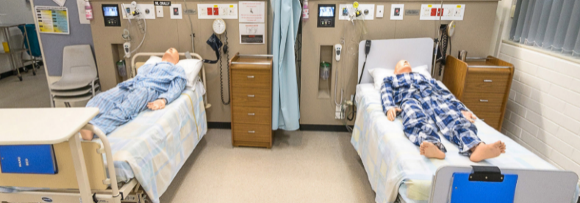 | Where you go when it all gets a bit too much
5. | 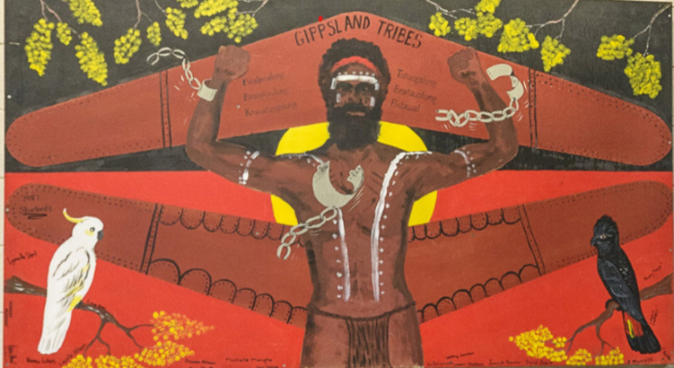 | Find our grass roots.
6. | 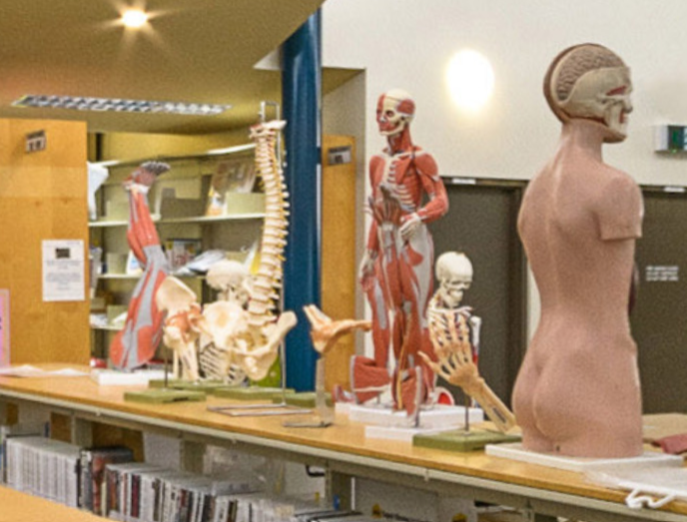 | This skeleton isn’t in a cupboard and not where you would expect. Look at the surrounds for a clue.
7. |  | Find the location of the centre of campus activity, where everyone likes to hang out
8. | 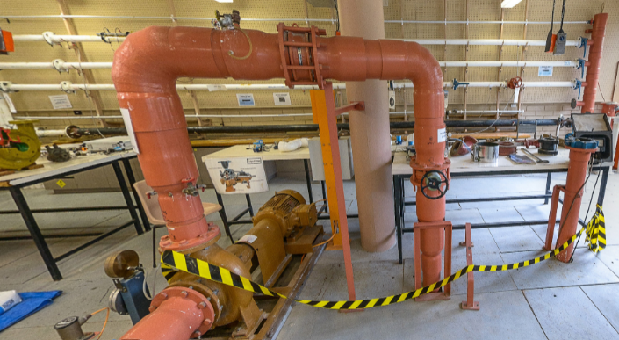 | When you need to build a solid foundation, where on Campus would you be?
9. | 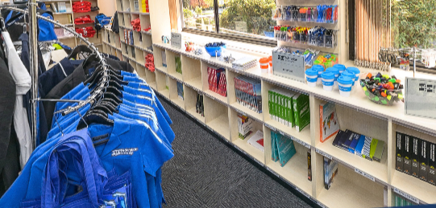 | From textbooks to drink bottles to uniforms, this is the one-stop shop. Where am I?
10. | 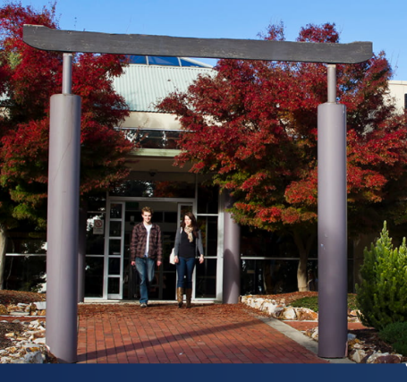 | Where is this Japanese influence on display?

ANSWERS:

- 6S Gallery Courtyard

- Sculpture Forest

- 3N Student Connect
- Health and Medical Advice
- Counselling or a Chaplain
- International Student Support
- Disability Support
- Financial Advice
- Careers and Employment Advice

- 2W Nursing

- 1S Aboriginal EC
The Aboriginal Education Centre provides support to prospective and current Aboriginal and Torres Strait Islander students.
Students are able to receive a broad range of educational and community support as all Federation University. As well as providing referral to services and support withing the University, our staff are available to provide personalised support.
- 1E Library.
Access resources online: books, journal articles, databases and websites. It it’s not online, postal loans service is always an option.

- SN Student Lounge

- 3W Mechatronics and Civil Engineering
With over 140 years delivering engineering education Federation University can provide the solid foundation you need to build a career in Civil, Mechanical, Mining and Mechatronics systems engineering

- 4N Fedliving & Fedstore

- Switchback Gallery. The entrance is flanked by torii, distinctive wooden gateways that mark the entrance to Shinto Shrines in Japanese

