Issue 7.
RAVE News

http://federation.edu.au/faculties-and-schools/faculty-of-education-and-arts/education-and-arts/research/rave-researching-adult-and-vocational-education
December 2016

Welcome
Professor Erica Smith, RAVE Convenor
In the current newsletter we report on activities of the Researching Adult and Vocational Education (RAVE) research group since June 2016.
Further information about all of our activities is available on our web site (see web link above) or email is on vet.research@federation.edu.au. Do not hesitate to email RAVE for more details about any items.
VET Research has been designated as a Research Priority Area of Federation University; and early next year there will be an official announcement with a change of name for our group. We are very excited about this development.
RAVE has administered two small grant programs this year, one program on VET teacher-education, for the Australian Council of Deans of Education Vocational Education Group; and one program on apprenticeship, for INAP, the international network on innovative apprenticeships. The projects are now almost complete. We would like to thank Fed Uni for hosting and administering the programs.
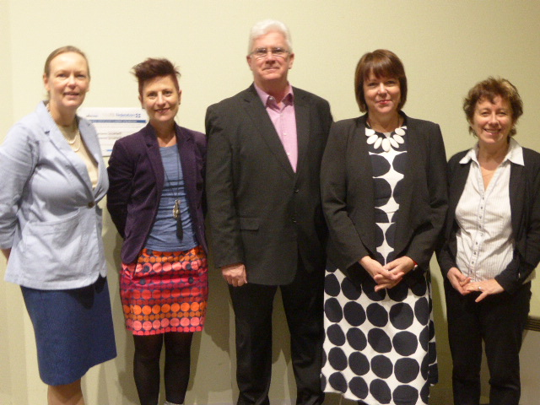
We have re-opened general admission into our qualification for VET teachers and trainers, the Associate Degree in Training and Education, but only into the stream for people who already have a Diploma of VET or VET Practice. In this stream you complete your Associate Degree with only six subjects’ study. The program is offered by distance education with optional workshops. On-site workshops may be provided for cohorts of staff at RTOs. Contact Erica Smith on e.smith@federation.edu.au or apply direct at:
https://study.federation.edu.au/#/course/1191
RAVE member Annette Foley was a member of the conference committee for the second annual VET teaching and teacher-education conference for 19 years, taking place on 8th and 9th December in Sydney. 130 people attended the successful event, and the keynote speakers were Stephen Kemmis and Berwyn Clayton The conference is organised by ACDEVEG, of which Erica Smith is national convenor. Next year’s conference will be at the Gold Coast, at the same time of year. We will keep you posted.

OctoberVET 2016
‘Teaching, training and learning: VET’s true business.’
For the ninth year running, RAVE (Researching Adult and Vocational Education) has hosted an ‘OctoberVET’ event. This year the Ballarat event took place at the SMB campus in Lydiard St, central Ballarat on Tuesday 18th October. The event was so popular that we have to change locations – 70 people attended.
The keynote speakers reported on two major projects in this area, ‘Investigating quality teaching in the Victorian VET sector’ (Project leader: Ruth Schubert, funded by the Victorian government), and ‘What makes a good VET teacher/trainer, and how do you get there?’ (Project leader: Erica Smith, funded by the Australian Research Council).
There were four other presentations about VET teaching/training and learning, three of which had an international flavour. All of the OctoberVET presentations can be viewed on the homepage of the RAVE website at https://federation.edu.au/faculties-and-schools/faculty-of-education-and-arts/research/fea-research-groups/rave-researching-adult-and-vocational-education
The 2016 Ballarat OctoberVET speakers (L to R): Dr Carolyn Johnstone, Fed Uni; Claire Rasmussen, Fed Uni; Fed Uni PhD candidate Les Burr, Wodonga TAFE; Keynote speakers Associate Professor Ruth Schubert, L.H. Martin Institute, University of Melbourne; and Prof Erica Smith, Fed Uni. Absent from photograph: Dr Mike Brown, Latrobe University.
Improving the quality, capability and status of the VET teacher workforce: Clare Rasmussen

Earlier this year Claire Rasmussen, Director of VET Practice at Fed Uni TAFE, completed a Fellowship through the International Specialised Skills Institute (ISSI) which involved visits to Germany, Switzerland and the UK. Concerned by the lack of strategy within Australia’s national VET system related to teacher professional identity and ongoing professional learnings she explored European professional development systems. She brought back some ideas Australia’s VET system could consider.
Claire’s report is now on the ISSI’s website: Improving the quality, capability and status of the VET teacher workforce.
The report identifies that there is:
- No national strategy to address VET teacher capability building
- No national strategy to address ongoing professional development
- No national VET teaching standards or criteria
- No national VET registration body
- No national approach or documented framework that articulates and measures engagement in a teacher’s ongoing professional learning against their vocational competency, currency, pedagogical skills and knowledge
- No national professional learning provider
- No national strategy to define what vocational currency, industry currency expectations.
Claire’s reports provides 13 recommendations for the Australian VET system to consider. These include:
- Recommendation 1: Raise the level of the minimum qualification beyond a Certificate IV in Training and Assessment; additional requirements are also needed to raise the quality of VET practice.
- Recommendation 2: Establish a set of nationally recognised VET learning and teaching standards. These standards must identify levels of capability to develop quality assessments, resources, training and assessment strategies for a broad range of student cohorts.
- Recommendation 9: That a minimum teaching practicum be a mandated part of the Training and Assessment Package of qualification for early career VET teachers and ensure that initial completion of these qualifications can’t be obtained through a full recognition of prior learning (RPL).
- Recommendation 10: Establish a national registration body that assists RTOs and in achieving full engagement in professional learning and professional standards.
Developments in VET and Adult Education in the Asian Region

RAVE researchers have been involved in activities in South East Asia recently.
Asia South Pacific Association for Basic and Adult Education (ASPBAE)
Carolyn Johnstone
One of the best adult education networks I have encountered is the Asia South Pacific Association for Basic and Adult Education (ASPBAE). This is a network of over 200 organisations and individuals, stretching from Uzbekistan in the west to the Cook Islands in the east. The group is passionate about the transformative power of adult education and learning throughout life, particularly for disadvantaged and vulnerable groups.
Against a backdrop of the adoption of the Sustainable Development Goals (SDG) and the Education 2030 Framework for Action, ASPBAE held a regional workshop in Bangkok on 20-21 November 2016 to plan its strategic directions for the next four years. I had the opportunity to meet educators, policymakers and community advocates and to share ideas about translating SDG 4 from an aspiration into specific actions in our “classrooms” – or wherever else we go with our students to learn. Each sub-region debated its own priorities, and the South Pacific group discussed capacity building for teacher education, and whether this should be the responsibility of governments or civil society organisations.. On Day 2, we split into groups to workshop ideas on how to refresh each of ASPBAE’s strategic priorities. I joined the group on capacity building for adult education. We discussed not only the excellent teacher training and leadership events which ASPBAE facilitates but also the potential for communities of practice and online resources that could be made available to the network. Although the atmosphere was somewhat subdued in recognition of the mourning for Thailand’s beloved monarch, ASPBAE’s regional workshop was a jam-packed two days. I collected business cards from potential collaborators from seven countries in the region, was stimulated to think about the SDGs through a community lens, and, most importantly, was energized by the commitment of colleagues to adult education.
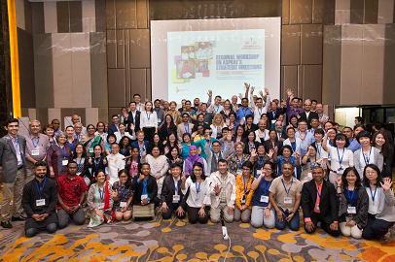
Asia South Pacific Association for Basic and Adult Education (ASPBAE), 2016.
TVET forum in South Korea
Erica Smith
I was an invited speaker at a TVET Forum: ‘Jobs, skills and strategies for the future: Perspectives from Asia-Pacific’, in Seoul on 5-6 October. The forum was organised by the International Labour Organization, the Korean Ministry of Employment and Labour, and HRD-Korea. I was privileged to speak alongside speakers from major international organisations such as the World Bank and the Asian Development Bank, as well as representatives of trade unions and employer groups from a range of Asian countries. I had been asked to speak about apprenticeship and fielded many questions from countries that are currently seeking to develop their systems.
One of the highlights for me was hearing a South Korean Professor, Soo-Bong Uh from Koreatech, give an impressively lucid account of the three streams of new technology and the ways that they will change work and therefore training. I was also fascinated to learn how Cambodia, one of the world’s least developed countries, was organising its VET system.

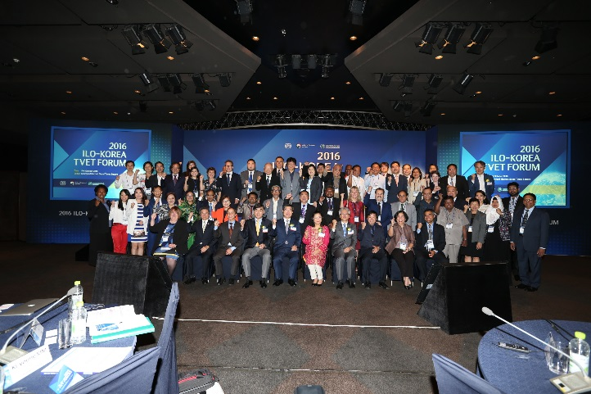
ILO-Korea TVET Forum, 2016

Research student news
To determine the considered differences between pre-apprentices and apprentices in skills, knowledge and assessment whilst learning on and off the job - PhD student, James Cannan (Soon to submit)
My research is focused on students studying Vocational Education at Institutes of Technology and at the workplace working as apprentices in New Zealand. In particular I have focused on the following areas:
- The relative merits of different modes of training for engineering trade occupations in New Zealand.
- The views of parties (employers, students, lecturers) of the different modes of training.
- The learning and assessment outcomes for different modes of training.
- Possible improvements to quality.
New Zealand has faced dramatic changes in tertiary education and particularly in the vocational education and training (VET) sector over the past 20 years, which have proved to be beneficial and substantially increased participation in education and training. There is now a far wider range of subjects to cater for the needs of trainees and learners in the vocational sector as the New Zealand population grows along with the engineering trade opportunities that are currently available in the workplace.
The trades covered in this study are engineering trades specifically in automotive and refrigeration/air-conditioning/electrical as these groups are typical of the trades groups across engineering disciplines studying at institutes of technology and at the workplace as apprentices.
The literature has clearly indicated that there is a lack of evidence to support the notion of quality training, and that there are several factors that could contribute to less than adequate training occurring in the VET sector. This study may be able to contribute further knowledge about what is meant by ‘quality’ learning and assessment practices by apprentices and employers, and how it is achieved through courses of study in VET.
I have been greatly supported in my study under the direction of Professor Erica Smith and Associate Professor Annette Foley.
“Engaged? or ‘It’s Complicated!’” – Masters minor thesis student, Dianna Burr (Completed)
I have been a teacher of further education for many years now, firstly in audio visual media and more recently in nursing. In 2013 I enrolled in the Master of Education Studies program offered to staff via the further/higher education partnership with Federation University and Wodonga Institute of TAFE. In 2014 I started my minor thesis as part of the research component, with Liz Atkins as my supervisor. My field of interest was to explore nursing academics’ perceptions of undergraduate Bachelor of Nursing students’ engagement with the course, as my higher education colleagues regularly provided positive feedback about our Diploma of Nursing graduates who went on to enrol in the Bachelor of Nursing program. I soon discovered that this was a relatively unexamined field of professional practice that required exploring.
My small scale study used a mixed methods qualitative phenomenographic approach to collect information. I asked 26 nursing academics to complete an online survey and participate in a follow up interview. Findings from the study showed that the nursing academics reported a complex range of levels of engagement relative to the entry level of the undergraduate nursing student. Students who undertake the Diploma of Nursing and subsequently articulate to the Bachelor of Nursing are perceived to be well prepared for studies in higher education; they are also perceived to be more fully engaged in learning. In contrast the current preparation for entry into higher education for direct entry and mature age students who have no recent higher education exposure is problematic. What is required is a national initiative for establishing more manageable articulation pathways for students who want to enter Enrolled Nurse or Bachelor of Nursing programs.

Future VET conferences
RMIT University School of Education Symposium: Reimagining Vocational Education in the Asian Century, 16-17 February 2017
Over the course of two days the School of Education's Centre for Education, Training and Work in the Asian Century will present research findings from leading academics and industry stakeholders to contribute to the rethinking of VE in the Asian Century. Drawing on a range of theoretical, methodological and empirical work from leading researchers, practitioners and thinkers (including Fed Uni’s Erica Smith), the symposium will identify, explore, map and debate the challenges and opportunities for reimagining adult and vocational education for the Asian Century. The symposium is open to researchers, vocational educators, policy makers and industry bodies interested in the future of vocational education.
For more information (a full program is forthcoming):
http://www.rmit.edu.au/events/all-events/conferences/2017/february/reimagining-vocational-education-in-the-asian-century.
Contact peter.rushbrook@rmit.edu.au

Adult Learning Australia: Getting of wisdom – Learning in later life.
International Exchange and Conferences (12-18 February, 2017) A unique collaboration between researchers in Europe, Australia & New Zealand
The conference has taken the Getting of Wisdom theme from a 1910 novel by Ethel Richardson (who also wrote as a male, Henry Handel Richardson) for an international exchange of people, researchers, policy makers and practitioners and ideas from opposite sides of the globe. Our aim is to acknowledge, share, listen to and learn from the accumulated wisdom of older people and researchers in the field to help secure and shape our diverse but interconnected futures.
The organisers have taken four intersecting themes - place, equality, empowerment and identity, and have woven these themes into the three conferences to be held in Australia and New Zealand 2017. Barry Golding from RAVE is one of the organisers.
Older learning in diverse contexts
14 February 2017 – Ballarat, Victoria, Australia
Learning later life and social inequalities
15 February 2017 – Melbourne, Victoria, Australia
Learning, empowerment and identity in later life
16 February 2017 – Wellington, New Zealand
Supported by: Adult Learning Australia (ALA), Federation University Australia, ACE Aotearoa & ELOA (Education & Learning by Older Adults) Network of ESREA (European Society for Research into the Education of Adults).
Single day registration in Ballarat is available from https://ala.asn.au/getting-wisdom-learning-later-life/

International Network on Innovative Apprenticeship (INAP) 2017 conference, ‘Modern apprenticeships: Widening their scope, sustaining their quality’.
You will remember that Fed Uni hosted the 6th conference of The International Network on Innovative Apprenticeship (INAP) in September 2015, which was opened by Minister Simon Birmingham. The 7th conference will be in the USA, in Washington DC next October. The theme is ‘Modern apprenticeships: Widening their scope, sustaining their quality’, and it will be held in the USA, in Washington DC. The conference will take place on the 2nd-3rd October at the US Bureau of Labor Statistics, adjacent to Union Station.
The event will feature several key topics on apprenticeship including: marketing apprenticeships to firms; trends and patterns in apprenticeship across countries; addressing occupational standards and assessing competence; costs and benefits of apprenticeships; governance and stakeholders; and more.
A call for papers will be issued within the next few weeks, together with details of keynote speakers. Information will be posted soon on the INAP web site at http://www.inap.uni-bremen.de/
RAVE members’ publications and achievements since RAVE News 6 (June, 2016)
Book chapters
Hodge, S. & Golding, B. (2016) Book Chapter in Strohschen, G., & Associates. (2016). The Metagogy project: A theorem for a contemporary adult education praxis. Foreword by A. Knox. Atlanta, GA: American Scholars Press. ISBN #978-0-9861817-2-6.
Smith, E. (2016). Links between concepts of skill, concepts of occupation, and the training system: A case study of Australia. In S. Loo & J. Jameson (Eds). Vocationalism in further and higher education: Policy, programmes and pedagogy. London: Routledge, 65-77.
https://www.routledge.com/Vocationalism-in-Further-and-Higher-Education-Policy-Programmes-and-Pedagogy/Loo-Jameson/p/book/9781138947047
Peer-reviewed journal papers
Hodge, S., Smith, E. & Barratt-Pugh, L. (2016). A model of Australian learning and development practice. International Journal of HRD Practice, Policy & Research. 1:2, 7- 25. http://dx.doi: 10.22324/ijhrdppr.1.113
Jin, A., Cooper, M. & Golding. B. (2016) Cross-cultural communication in teacher education: A case study of an Australian pre-service teacher placement in Liaoning, China. Australian Journal of Teacher Education, 41(6), 20-34.
Kimberley, H. & Golding, B. & Sions. B. (2016) The Company of Others: Generating knowhow in later life, International Journal of Lifelong Education, 35(5) pp. 1-12.
Smith, E. & Teicher, J. (published on-line October 2016). Re-thinking skill through a new lens: Evidence from three Australian service industries. Journal of Education and Work.
http://dx.doi.org/10.1080/13639080.2016.1243231
Refereed conference papers
Foley, A. (2016) Youth re-engagement: Developing capabilities through a human development approach. Association for Research in Post-Compulsory Education (ARPCE) 2nd International Conference, June 2016.
Smith, E. & Junor, A. (2016). Using multiple iterative research methods in a national research project. ACSPRI (Australian Consortium for Political and Social Research Inc.) Social Science Methodology Conference, University of Sydney, 19-22 July.
Smith, E., & Yasukawa, K. (2016). Views of VET teachers, managers and students about VET teacher qualifications. Putting VET research to work: Collaboration, Innovation, Prosperity. 19th Annual AVETRA conference, TAFE Northern Sydney campus, 21-22 April
Non-refereed publications
Smith, E. (2016) ‘Apprenticeship: One concept, many facets’, Guest editorial, special edition of Education + Training, 58(6), http://www.emeraldinsight.com/doi/full/10.1108/ET-05-2016-0083
Other reports
Golding, B. & Brown, M. (2016) Rural ‘Sporting Chance’, JOYCA Trust/ Macpherson Smith Rural Foundation Scholarship Design Research Project, Final Report Part 1, Tertiary Tracks, Kingston & MSRF, Creswick.
Golding, B. (2016) Learning beyond the mainstream: ‘Here everything’s different’, A Multi site evaluation of Alesco-type learning centres, Final Report, 15 August 2016, Tertiary Tracks, Kingston, win conjunction with WEA Hunter, Newcastle. (54 pages) AlescoFinaltoWEAHunter15Aug2016
Non-refereed conference papers
Johnstone, C. (2016). The Australian Army and the national system of Vocational Education & Training (VET) – working together? From Boom to Bust: Australian Historical Association 2016 Conference. Ballarat, 5 – 8 July.
Johnstone, C. (2016). Supporting pre-service teachers through intercultural experiences: internationalisation of teacher education. Education: A Global Perspective, British Educational Research Association Special Interest Group Event. Worcester, UK, 21 – 22 June.
Johnstone, C. (2016). Individual dignity and the role of adult education. Meeting the Challenges of Development and Dignity; Conference of the Academic Council on the United Nations System. Fordham University, New York, USA, 16 – 18 June.
Smith, E. (2016). Can quality apprenticeships be an answer for meeting future skills demands? Invited speaker, TVET Forum: ‘Jobs, skills and strategies for the future: Perspectives from Asia-Pacific.’ ILO, Korean Ministry of Employment and Labour, and HRD-Korea, Seoul, 5-6 October 2016.
Smith, E. & Tuck, J. (2016) ‘I place myself in the shoes of a learner’: VET teachers’ and trainers’ descriptions of their practice. Research, Policy & Teaching Practice: Building connections: 2016 National Conference on VET Teaching & VET Teacher Education, University of Technology, Sydney.
Smith, E. (2016). What makes a good VET teacher/trainer and how do you get there? Teaching, training and learning: VET's true business: OctoberVET 2016, Federation University, Ballarat, 26 October, Plenary speaker.
Smith, E. (2016). ‘How to reframe debates about quality after the VET FEE-HELP scandal’, Criterion conference ‘Driving quality’ 27-28 July 2016, Melbourne. Invited plenary speaker.
Smith, E. (2016): Re-qualifying the further education teaching workforce in Australia: How research evidence can help. Vocational Teacher Education in the 21st Century: Oppor-tunities and Challenges conference. Stirling, June 24 2016.
Smith, E., Yasukawa, K. & Harris, R. (2016). Do the qualifications of Further Education teachers make a difference? The views of managers and departmental heads in training providers. Research in Post-Compulsory Education’s 2nd International Research Conference of FERA, Harris Manchester College, Oxford, 8-10 July.
Smith, E. (2016). Researchers’ responses to post-compulsory education policy in recent times: A provocation. Adult Education in Austere Times:43rd annual conference of SCUTREA, the Standing Conference on University Teaching and Research in the Education of Adults, College Conference Centre, University of Leicester, 5-7 July
Other activities and awards
Smith, E. Featured author on VOCEDPLUS database pod (NCVER/UNEVOC) on apprenticeship http://www.voced.edu.au/pod-apprenticeships-and-traineeships
Smith, E. (2016). Internal competitive grant: with Tim Harrison (Fed Uni), Young futures in regional towns pilot project, Fed Uni Faculty of Education and Arts, $6,335.
Smith, E. (2016). Engaging with employers in emerging economies: India, A snapshot in 2012 and 2015. Engaging Employers in Skills Development for the 21st Century, Invitation only symposium organised by the Commonwealth Department of Education and Training and the OECD, Adelaide, 2-3 June.
Smith, E. Invited participant in NCVER ‘Apprenticeships Stakeholder Forum: The future of Australian apprenticeships’, Canberra, 25 October 2016.
Smith, E. Invited to national symposium of ‘thought leaders’ on the future of Training Products, NCVER and Victorian Department of Education and Training, 9 August 2016.

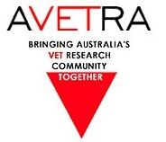
Australian Vocational Education and Training Research Association

AVETRA 2017 Conference

Renovate or Rebuild? Exploring the architecture of VET
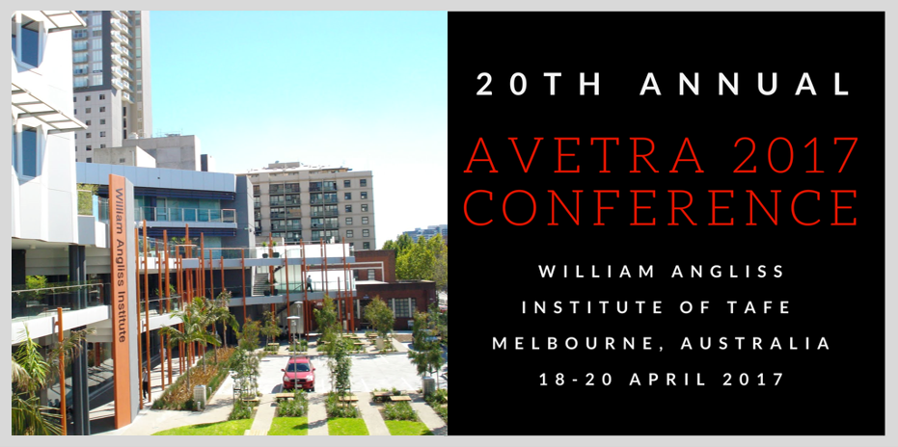

20TH Annual AVETRA Conference
18-20 April 2017
William Angliss Institute of TAFE
Melbourne, Australia

- 9 Concurrent Sessions of 5 streams each
- Showcasing over 45 papers from researchers around Australia
- Two confirmed keynote speakers: Peter Noonan and John Polesel
- Panel and workshop sessions incorporated into the program
- Gala Dinner & Welcome Reception included as part of the program

https://avetra.org.au/upcoming-conference

