NO: | FIND: | HINT: | ANSWER:
1. | 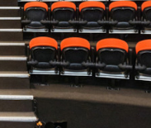 | Do you have what it takes to perform?
2. | 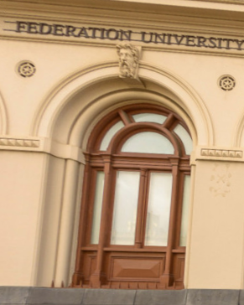 | There is lots to see here but there won’t be any letters!
3. | 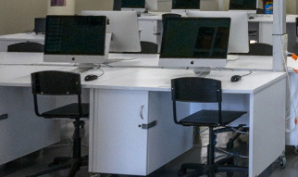 | Do you want to be able to communicate on a professional level?
4. | 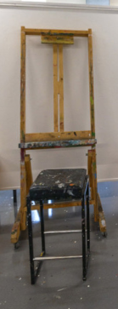 | Let your Picasso flow!
5. | 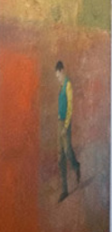 | Art on display, but it isn’t being sent anywhere
6. | 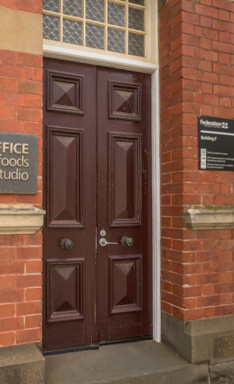 | Maybe you would like to perform for the Sheriff in his office?
7. | 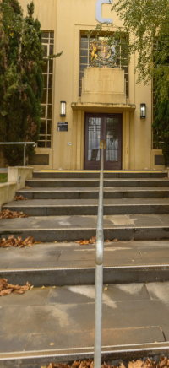 | Where making an entrance counts
8. | 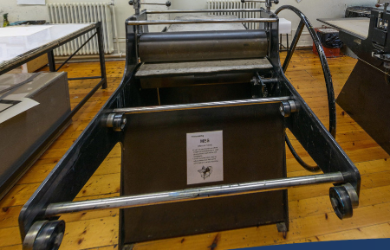 | It can be messy working with ink!
9. | 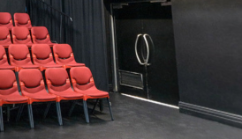 | Performing can be done out of a box!
10. | 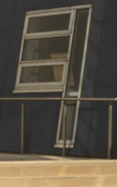 | Which direction are you heading in to?

ANSWERS:
1. Helen Macpherson Smith Theatre
2. Post Office Building
3. Communication Design - The Design Studio features large open plan teaching areas, audio visual facilities and a design resource area.
4. Visual Arts – Painting. Build your specialist skills through practical studio based workshops of experimentation and self-discovery
5. Post Office Gallery

6. Old Sheriff’s Office

7. Camp St Entrance
8. Visual Arts – Printmaking. Specialized facilities for work in ceramics/3D materials, drawing, printmaking, photography and painting.

9. Post Office Box Theatre

10. North Entrance

