NO: | FIND: | HINT: | ANSWER:
1. | 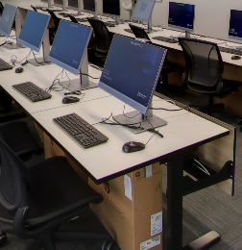 | Where it’s all done on screen!
2. | 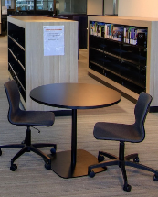 | Where an infinite number of resources are readily available for you.
3. |  | One of the places to go when you need to be lectured!
4. |  | Where you can knuckle down with friends to study
5. | 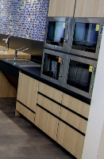 | When sustenance is required
6. | 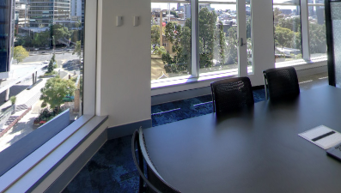 | A place to meet, in a room with a view
7. | 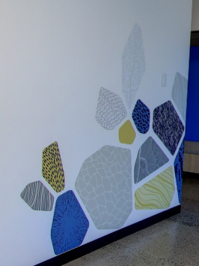 | Where you can expect to be greeted with a smile.
8. | 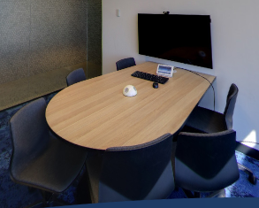 | A quiet place to study in a group
9. |  | Where you need to make a break for it.
10. |  | A place to go to get some fresh air.

ANSWERS:
- Lvl 8 - Computer Room
- Lvl 7 - Library
- Lvl 8 - Lecture Room
- Lvl 8 - Study Booths
- Lvl 5 - Kitchen
- Lvl 7 - Meeting Room
- Lvl 5 - Reception
- Lvl 7 - Student Study Space
- Lvl 6 - Breakout Space 2
- Lvl 5 - Balcony

