For candidates applying for promotion to Level C, D and E
Process | 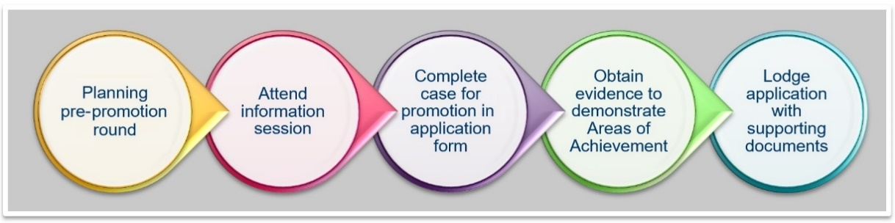
- Planning pre-promotion round
1.1 | Check that you are eligible to apply for promotion under the Academic Promotion Procedure for Levels C, D and E.
1.2 | Discuss your intention to apply for promotion with your performance supervisor and record this in your performance development plan.
1.3 | Familiarise yourself with the following:  Academic Promotion Procedure for Levels C, D and E  Criteria framework including:  - Teaching and Learning criteria including reference to FedUni Teaching Expectations (Part B)  - Research and Creativity criteria  - Leadership, Engagement and Academic Citizenship  - Collect sufficient evidence and material to support your academic achievements.
1.4 | Check the Academic Promotion key dates  Candidates seeking for promotion to Level D and E are expected to be interviewed.

- Attend an Information Session
Attend an Academic Promotion information session (as appropriate).
- Female academic staff are also encouraged to attend an additional women’s academic promotion information session.
Session details can be found at Academic Promotion key dates
Bookings for these sessions must be made by e-mailing: hr@federation.edu.au.

- Complete case for promotion form
3.1 | Access the relevant supporting material for candidates applying for promotion.  The material is available on the academic promotion web page.
3.2 | Meet with your PRDP supervisor and Dean to discuss your application
3.3 | To assist academic promotion committees in their assessment of your case for promotion, you should ensure that your case and supporting evidence:  - informs the committee about your activities in relation to your discipline (e.g. publishing one paper a year in one discipline might not be understood by a staff member whose discipline produces an average of five papers per year);  - is concise, clear and coherent (e.g. use dot points if appropriate and clear headings);  - indicates your academic achievements (e.g. focus on activity, outcome and impact);  - focuses on quality rather than quantity;  - refers to the relevant academic performance framework, including the education, research and engagement criteria/practice elements as required;  - provides a complete and clearly labelled case and evidence that supports your achievements; and  - clearly specifies any relevant circumstances (if applicable) to enable an assessment relative to opportunity.  TIP: Ask a colleague (outside your discipline) to check how your application presents and that the structure is logical.
3.4 | Complete and sign all relevant sections in your Case for Promotion form.
3.5 | Compile your supporting evidence (where relevant).
3.6 | Allow your Dean/PRDP Supervisor enough time during the promotion round to complete their sections of the case for promotion form.
3.7 | Ensure that the completed case for promotion form is signed by your Dean/Director/DVC before submitting by the closing date of the promotion round.

- Completing and submitting your application
Before submitting your application, check the following on your final Case for Promotion form:
I have observed the word limits.
All sections have been completed and signed.

- Level D and E candidates: prepare for an interview
The purpose of the interview is to clarify information contained in your application and to allow you to answer questions from the committee regarding your case for promotion. The interview is typically around 10 to 15 minutes.
You will be expected to be familiar with your application, and the committee may ask you questions to clarify components of your case. You are encouraged to:
- be punctual;
- bring a copy of your application;
- answer questions clearly and concisely; and
- be prepared and take the opportunity to communicate the strengths of your application.
An interview guide will be provided to prior to the committee meeting.

