TAFE Students -
How do I view my unofficial transcript

my Student Centre | mysc.federation.edu.au | 1800 FED UNI

How to obtain an unofficial transcript

Important:
Unofficial transcripts allow you to view or print a copy of your current results. They clearly state they are NOT authorised Assessment Statements and, they will not have supporting signatories.

Steps: Login to my Student Centre by going to mySC.federation.edu.au
- Enter your User ID number (student ID) and Password, then select the button.
If you are having trouble logging into my Student Centre please contact the Service Desk on servicedesk@ballarat.edu.au or 53279999

- On the right hand side of your screen you will see the Academics section. Click on the drop down list
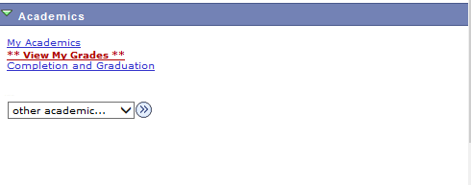

- Click the Transcript: View Unoffical list item

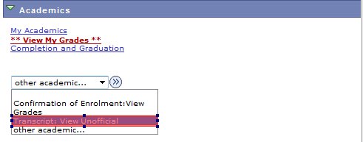

- Click the Go button

- The View Unofficial Transcript page will display an Academic Institiution and a Report type. Click on the drop down list by the report type.
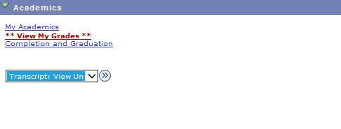

- Click on the Unofficial Transcript list item
- Click the button
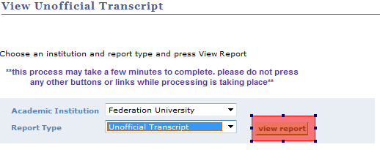

Important:
When you click the View Report button a PDF file will open in a new window. If you have Holds on your account – your transcript will not open. If you have a pop up blocker- you should turn it off for this website or the PDF will not open. To request an Official Transcript, please use the link provided on you my Student Centre Home page. Complete the form and send it in to Student Services.

- An unofficial transcript will be generated which you can Print or Save for future reference.
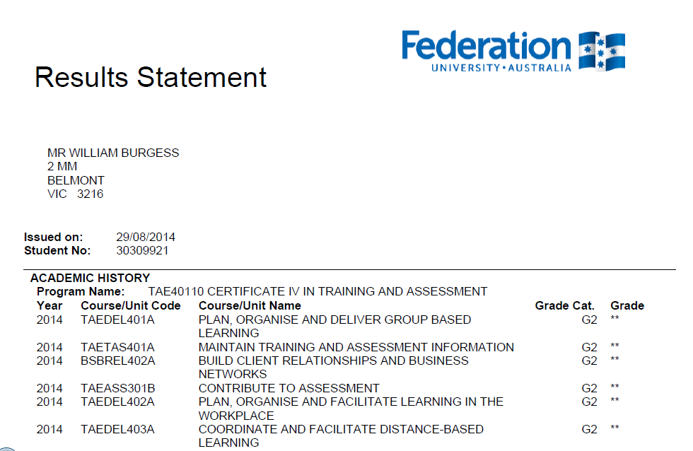

- Click the close tab to return to my Student Centre

- Click the link to return to the Home Page.

