TAFE Students -
How do I pay my outstanding fees

my Student Centre | mysc.federation.edu.au | 1800 FED UNI

How to pay outstanding fees
Important:
To pay outstanding fees you will be directed to an online banking option via ANZ egate.

Steps: Login to my Student Centre by going to mySC.federation.edu.au
- Enter your User ID number (student ID) and Password, then select the button.
If you are having trouble logging into my Student Centre please contact the Service Desk on servicedesk@ballarat.edu.au or 53279999

- On the right hand side of your screen you will see the Finances section. Locate the make a payment hyperlink.

- Click the link

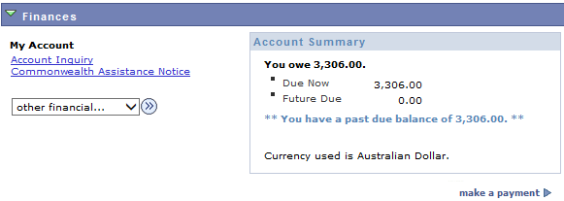

- On the make a payment page – Enter the Amount you wish to pay in the Field.
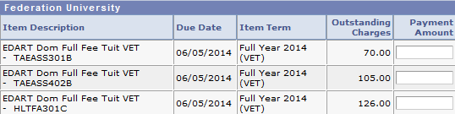

- When you have entered all amounts click the button
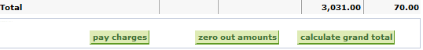

- After checking the Payment Summary amount is accurate, Click the button.

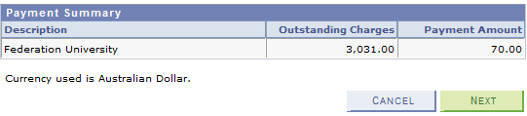

- If you are ready to make a direct payment Click the button. You will be dircted to ANZ eGate where you can complete the payment process.

