**TAFE Students -**

**How do I view my grades**

my Student Centre | mysc.federation.edu.au | 1800 FED UNI

**How to View Grades**

**Important:**

The following document explains how you can view your grades in my Student Centre.

Your grades are available to view in my Student Centre after they have been published.

If you are unable to view your grades, reasons might include one of the following. You have not been graded yet, your grades have not been published yet or you have a hold on your student record. A hold can be put on a student's account if there are outstanding fees, e.g. late fees for library books.

Steps: Login to my Student Centre by going to mySC.federation.edu.au



1. Enter your **User ID** number (student ID) and **Password**, then select the button.

If you are having trouble logging into my Student Centre please contact the Service Desk on [servicedesk@ballarat.edu.au](mailto:servicedesk@ballarat.edu.au) or 53279999

1. On the right hand side of your screen you will see the Academics Section section.

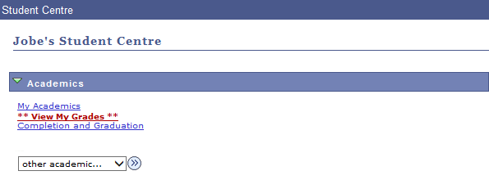



1. Click the list item



1. Here you will see your page.

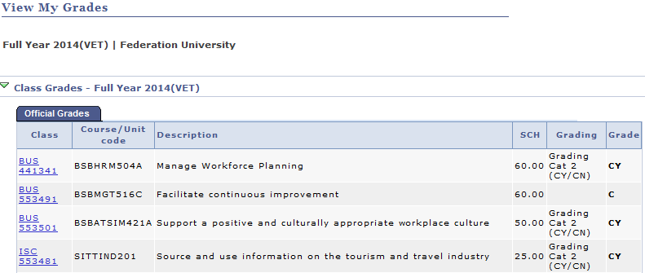

1. Click the  link to return to the home page.