TAFE Students -
How do I view my Confirmation of Enrolment

my Student Centre | mysc.federation.edu.au | 1800 FED UNI

How to obtain a confirmation of enrolment form

Important:
The VET confirmation of enrolment form can be used to provide evidence of your study to Centrelink.
You will need PDF software installed on your computer to view the VET Confirmation of Enrolment form

Steps: Login to my Student Centre by going to mySC.federation.edu.au
- Enter your User ID number (student ID) and Password, then select the button.
If you are having trouble logging into my Student Centre please contact the Service Desk on servicedesk@ballarat.edu.au or 53279999

- On the right hand side of your screen you will see the Academics section. Click on the drop down list
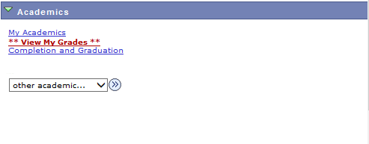

- Click the ‘Confirmation of Enrolment: View’ list item
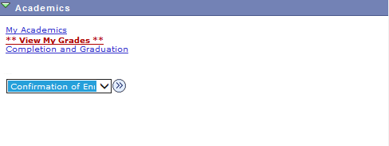

- Click the Go button

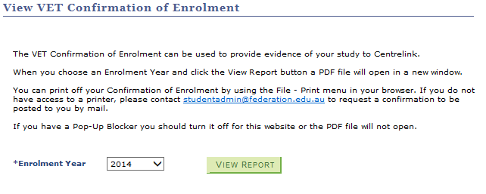
- The View Confirmation of enrolment page will display an Enrolement Year and a View Report button. Check the Year you wish to generate the form for is correct – for example, 2014, and click the button.

- The confirmation of enrolment document will open in PDF in another window. If you wish, you can print or save the PDF document. Click the close tab to return to mySC.
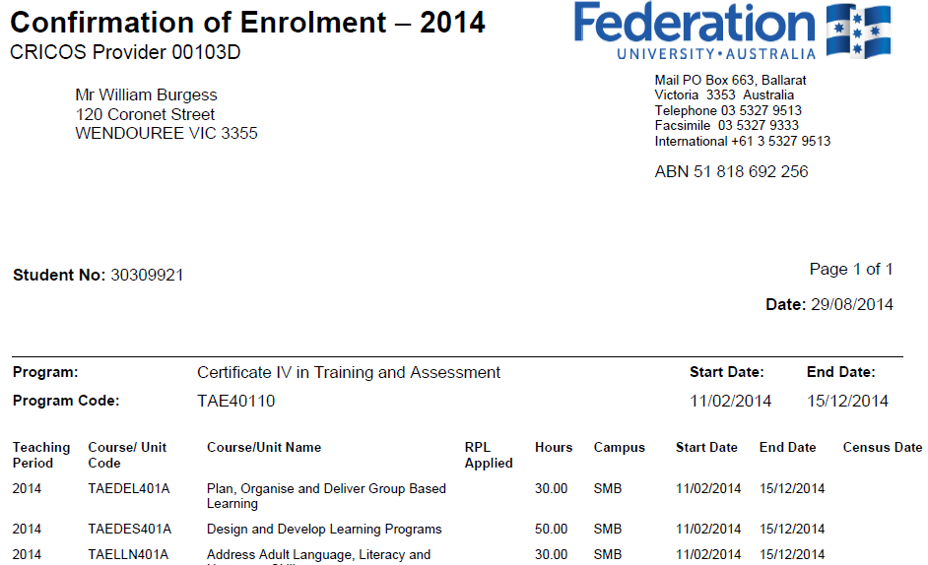

- Click the link to return to the Home page.

- Congratulations. You have successfully viewed your Confirmation of Enrolment form.

