TAFE Students -
How do I update my personal details

my Student Centre | mysc.federation.edu.au | 1800 FED UNI

How to update personal details
Important:
During the enrolment process you were asked to check and confirm your personal details such as addresses, phone numbers, email addresses, names and your emergency contact details.
If this information changes during your time of study at the University, you can update it via the ''Personal Information'' section on your my Student Centre home page.

Steps: Login to my Student Centre by going to mySC.federation.edu.au
Enter your User ID number (student ID) and Password, then select the button.
If you are having trouble logging into my Student Centre please contact the Service Desk on servicedesk@ballarat.edu.au or 53279999

1. How to Change your address

- On the right hand side of your screen you will see the Personal Information Section. Find theContact Information Section.

- Click the hyperlink that identifies the item you wish to update. For this example – Click
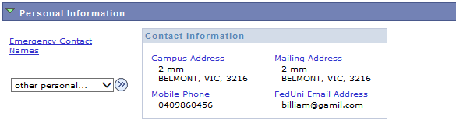

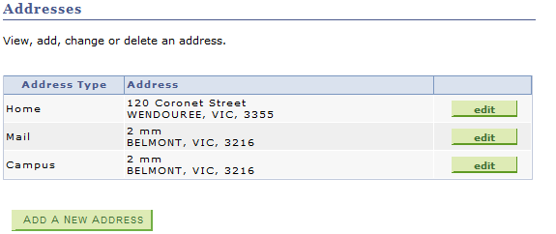
- Choose the address type you are updating and Click the button

- Type in the correct address, using the look up icon to ensure the correct suburb and postcode are entered and click the button.
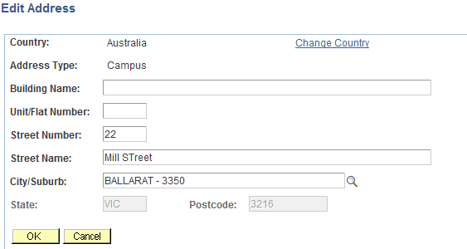

- The Change Address page will show your new address. Click the button
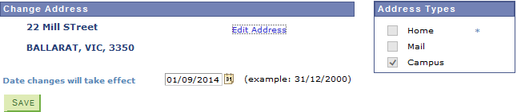

- The Change Address Confirmation will show that the Save was successful
- Click the button to return to the personal information page.
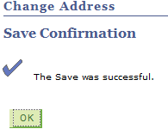

2: How to Change your Phone Number

- Click on the link to add or update a phone number
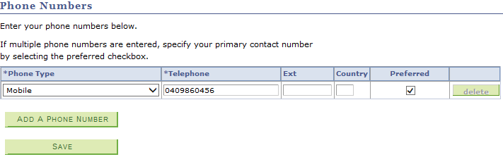

- Click the button to add a phone number

- Select the phone type from the Drop down list (for example Home) and enter the number. Ensure you click the Preferred contact number. If you just wish to edit an exisiting number, simply type over the old number and click save.
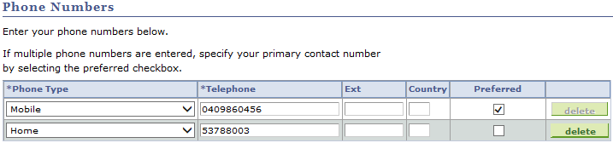

- Click the button

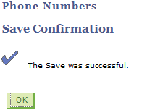
- The Save Confirmation will show success Click the button to return to the personal details page,

3: How to Change your email address

- Click on the link to add or update an email address.

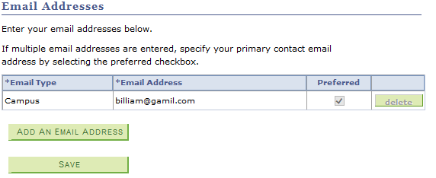

- Click the button to add an email

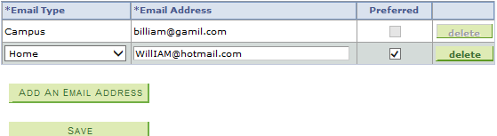
- Select the email type from the Drop down list (for example Home) and enter the email address. Ensure you click the Preferred email address.

- Click the button

- The Save Confirmation will show success Click the button to return to the personal details page,

4: How to Change your Emergency Contacts

- Click on the link to add or update an emergency contact

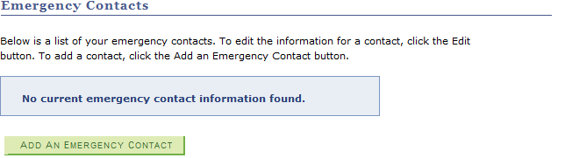

- Click on the button

- Enter in your Emergency contact details
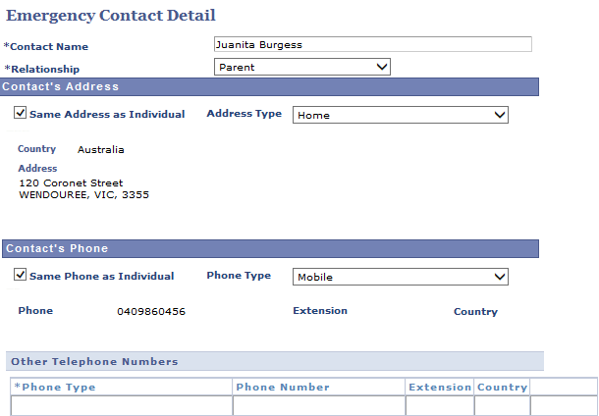

- Click the button

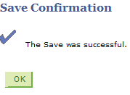
- The Save Confirmation will show success Click the button to return to the personal details page

6: How to Change your name

- Click on the link to update/correct your name details
- Click on the button to change a name
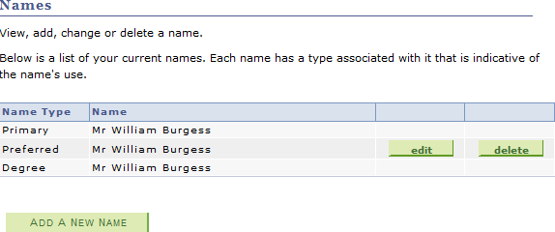

- Enter the changes you wish to make to your name

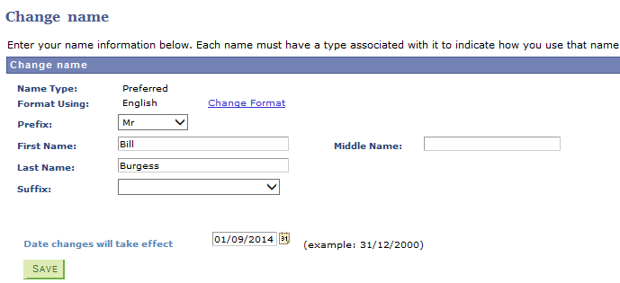

- Click the button

- The Save Confirmation will show success Click the button to return to the personal details page

