TAFE Students -
How do I view my invoice

my Student Centre | mysc.federation.edu.au | 1800 FED UNI

How to view an Invoice

Important:
After you enrol, your fees will be calculated and an email notification will be sent to your student webmail account when an invoice/statement is issued. Your online invoice is available to be viewed and printed from you r my Student Centre account. Fees are due for payment by the date specified on your invoice/statement.

Steps: Login to my Student Centre by going to mySC.federation.edu.au
- Enter your User ID number (student ID) and Password, then select the button.
If you are having trouble logging into my Student Centre please contact the Service Desk on servicedesk@ballarat.edu.au or 53279999

- On the right hand side of your screen you will see the Finances section. Click on the drop down list
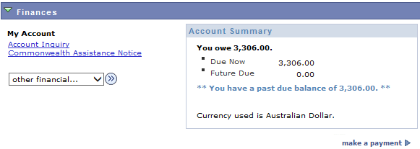

- Click the ‘Charges Due’ list item
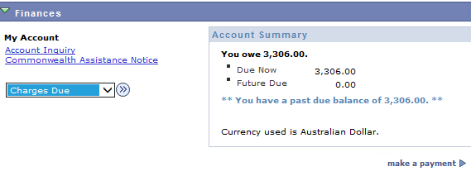

- Click the Go button

- The Charges due page will show any outstanding charges.

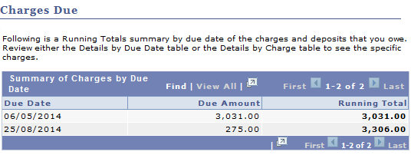

- Scroll to the bottom of the page to view invoices.

- You will see an Invoice Number and Invoice amount

- Click on the Invoice Number: . This will open another window and enable you to generate a Tax Invoice/Statement.
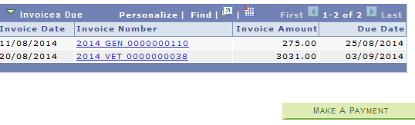

- Click the Close tab button to return to my Student Centre

- Click the link to return to the Home page.

