TAFE Students -
How do I provide my bank details for refund purposes

my Student Centre | mysc.federation.edu.au | 1800 FED UNI

How to provide bank details for refund purposes

Important:
To receive a refund you will need to provide your personal banking details to allow a direct deposit to occur.

Steps: Login to my Student Centre by going to mySC.federation.edu.au
- Enter your User ID number (student ID) and Password, then select the button.
If you are having trouble logging into my Student Centre please contact the Service Desk on servicedesk@ballarat.edu.au or 53279999

- On the right hand side of your screen you will see the Finances section. Locate the make a payment hyperlink.

- Click the link
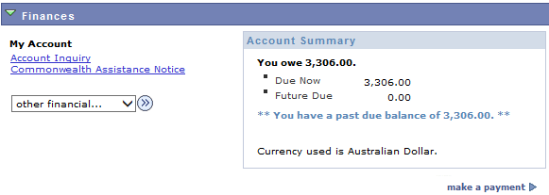

- On the make a payment page - Click the tab
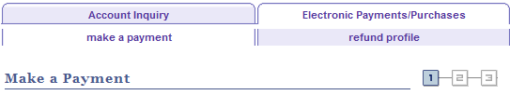

- A Refund Profile Page will appear. Click the drop down list to show Bank Deposit.

- Click the Bank ID look up icon to find your Banking Organisations

- Click the Branch ID look up to access your Branch ID.
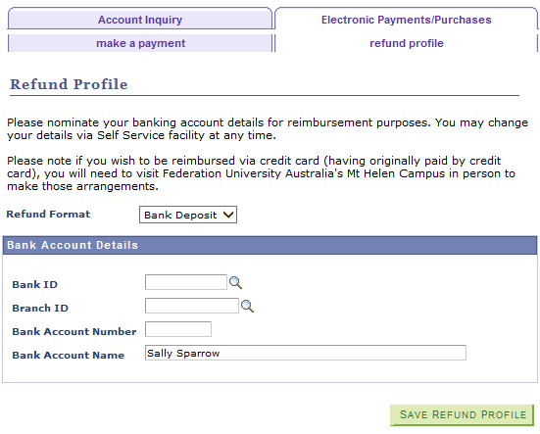

- To assist you in finding your Branch ID - Click the ‘Search by: list items’
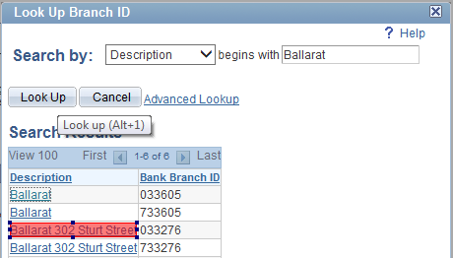
- Click the Description option and enter your brach location. For this example we have used Ballarat.

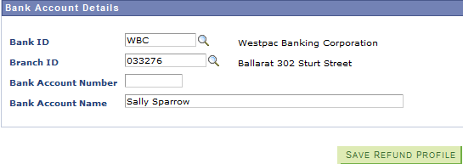

- Enter your Bank Account Number
- Click the button.

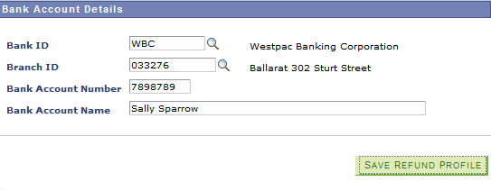

- Click the link to return to the home page.

