TAFE Students -
How do I view my Commonwealth Assistance Notice (CAN)

my Student Centre | mysc.federation.edu.au | 1800 FED UNI

How to View a Commonwealth Assistance Notice (CAN)
Important:
Your Commonwealth Assistance Notice will be available to you after the census date if you have FEE HELP or VET FEE HELP. You will receive an email notification when the form is available to you in my Student Centre.
Your CAN includes important information about your enrolment, any HELP debt you have incurred, loan fee you may have incurred and/ or any student contribution amounts you have paid.

Steps: Login to my Student Centre by going to mySC.federation.edu.au
- Enter your User ID number (student ID) and Password, then select the button.
If you are having trouble logging into my Student Centre please contact the Service Desk on servicedesk@ballarat.edu.au or 53279999

- On the right hand side of your screen you will see the Finances Section.

- Click on the link

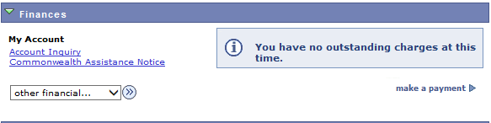

- Click the link
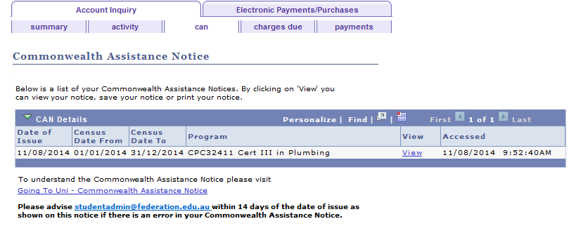

- A PDF version of your CAN will appear in another window provided you have the appropriate software.
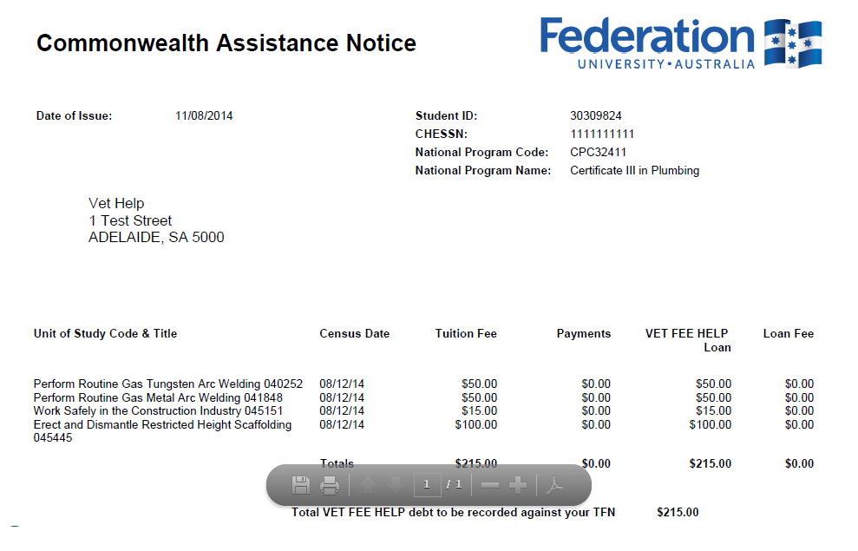

- Click the Close tab to close the window

- Click the link to return to the Home page

